Simulated Nmap Scan - Packet Tracer
-----------------------------------

Scanner: KaliSim (192.168.10.100)
Targets:
- PC0: 192.168.10.10
- PC1: 192.168.10.11
- PC2: 192.168.10.12

Ping Results:
- All hosts responded to ICMP Echo Requests

Simulated Port Scanning:
- Attempted to probe common ports using telnet (22, 80, 443, etc.)
- All targets were reachable from KaliSim

Conclusion:
The internal network is functioning, and basic service reachability was demonstrated using simulated scan techniques inside Packet Tracer.
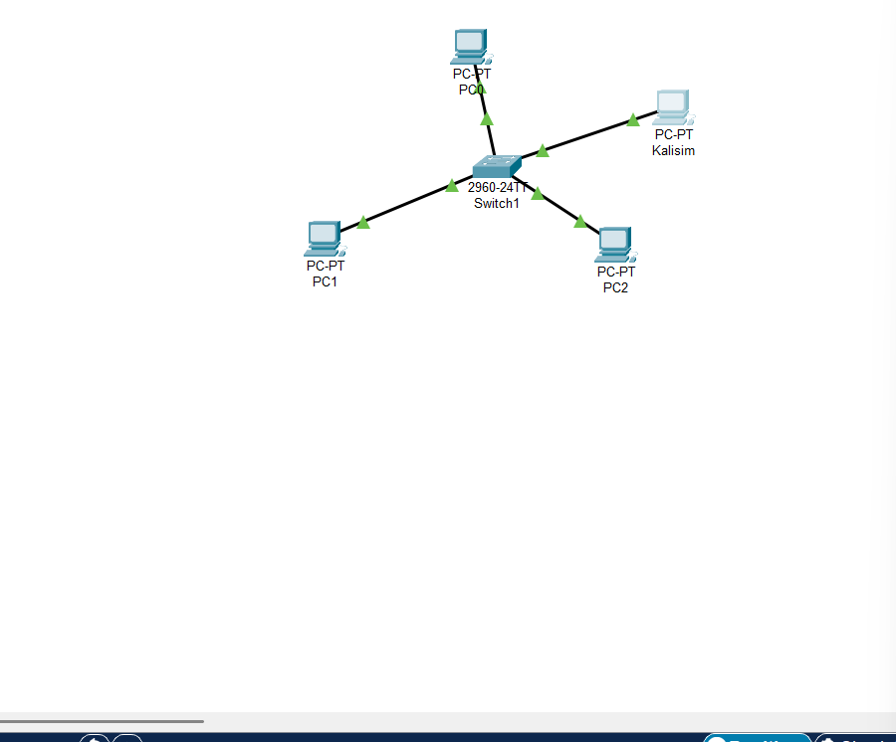
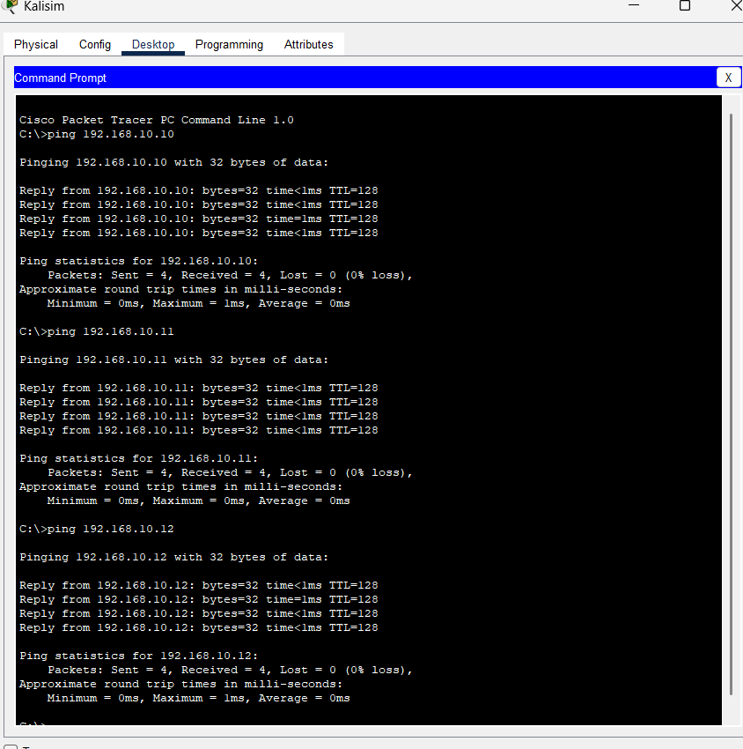

Due to Packet Tracer’s limitations and lack of direct integration with real NICs or external tools like nmap, this project simulates a typical Nmap full-port scan scenario using ICMP (ping) and CLI tools such as telnet within the PT environment. The scan process and results are outlined in the attached .docx and .txt log.

